HYBRID RETRIEVAL-AUGMENTED GENERATION SYSTEM
FOR TAMIL PONNI ARCHIVE

ABSTRACT
This work presents Ponni RAG, a hybrid Retrieval-Augmented Generation (RAG) system designed for Tamil literary and historical archives, specifically the Ponni magazine collection (1947–1955). The system addresses three major challenges: digitizing legacy Tamil documents, enabling accurate retrieval in a morphologically complex language, and organizing archival articles into meaningful categories without dependence on continuous online processing.To improve retrieval quality for Tamil archival text, the proposed system combines dense semantic retrieval, sparse BM25-based lexical retrieval, and multilingual cross-encoder reranking within a unified hybrid search pipeline. Tamil-specific normalization and adaptive evidence selection strategies are incorporated to handle orthographic variation, rich morphology, and noisy historical OCR text. The system further includes an offline article classification framework covering 15 content categories and a dual-prompt response generation architecture for both semantic and structured queries.Evaluation was conducted using a curated dataset of human-verified Tamil question-answer pairs spanning literary, historical, and cultural topics. Experimental results demonstrate that the hybrid retrieval and reranking architecture substantially improves retrieval precision and response relevance for multilingual Tamil archival question answering.
Keywords: Tamil NLP · Retrieval-Augmented Generation · Hybrid Retrieval · Cross-Encoder Reranking · Digital Archives · Question Answering

1 INTRODUCTION
Tamil is one of the world's oldest living languages, with a written literary tradition spanning over two millennia. Despite this heritage, a large body of mid-20th century Tamil periodical literature remains largely inaccessible in digital form. Ponni magazine, published from 1947 to 1955 across eight volumes, represents an important record of Tamil cultural, political, and literary thought during the post-independence era. Making this content searchable and queryable presents unique challenges rooted in Tamil's complex grammar, script, and historical printing variations.
Retrieval-Augmented Generation (RAG) has emerged as a powerful approach for grounding AI-generated responses in specific document collections, reducing hallucinations and improving factual accuracy. However, most existing RAG systems are designed primarily for English and other morphologically simpler languages where conventional keyword retrieval performs adequately. Tamil presents significantly greater challenges due to its rich morphology, agglutinative word structure, and orthographic variation, where a single root word may appear in dozens of grammatical forms. As a result, purely lexical retrieval methods often fail to identify semantically relevant documents. To address this limitation, Ponni RAG combines dense semantic retrieval, sparse BM25-based retrieval, and multilingual cross-encoder reranking to improve retrieval precision across Tamil archival content.
This paper presents Ponni RAG. Our principal contributions are:
- A complete pipeline for extracting, organizing, and indexing individual Tamil literary articles from multi-article document volumes, preserving author and structural metadata.
- A hybrid retrieval architecture combining dense semantic search, sparse BM25 keyword retrieval, and multilingual cross-encoder reranking for improved Tamil-language retrieval precision.
- A dual-prompt AI response system that routes queries to the most appropriate response strategy depending on the nature of the question.
- A fully offline article classification system covering 15 content categories using rule-based matching with a statistical fallback.
- A Tamil-specific evaluation framework using a composite scoring method that accounts for Tamil's morphological complexity, evaluated on 50 human-annotated question-answer pairs.
The proposed system emphasizes robust multilingual retrieval for low-resource archival content through a combination of semantic embeddings, sparse lexical search, adaptive reranking, and Tamil-aware normalization strategies. The architecture is designed to operate efficiently in both online and resource-constrained deployment environments while preserving retrieval accuracy for historical Tamil documents.
The remainder of this paper is organized as follows. Section 2 reviews related work. Section 3 describes the system architecture. Section 4 presents the article classification system. Section 5 describes the evaluation framework. Section 6 covers deployment. Section 7 discusses challenges and limitations. Section 8 concludes.
2. BACKGROUND AND RELATED WORK
2.1 Retrieval-Augmented Generation
RAG systems improve AI responses by first searching relevant documents from a collection and using that content to guide the answer. This reduces the tendency of AI models to generate incorrect or fabricated information. Ponni RAG uses a hybrid search approach that combines semantic and keyword signals, which consistently outperforms either method used alone.
2.2 NLP for Tamil
Tamil is a Dravidian language with complex word formation rules. A single word can encode root, tense, number, person, and grammatical case all at once, making simple keyword search unreliable. Multilingual language models that understand semantic meaning across languages have shown reasonable performance for Tamil, and Ponni RAG uses such a model as its core search engine. All scoring metrics in the system operate at the character level to correctly handle Tamil's word variation.
2.3 Digital Humanities and Archival NLP
The use of NLP for historical archives has produced systems for newspaper analysis, manuscript digitization, and archival search. Challenges specific to historical Tamil periodicals include non-standard spelling, inconsistent diacritical marks, and the absence of clean digital text in scanned sources. Ponni RAG addresses these through careful text extraction, character normalization throughout the pipeline, and approximate matching for author name disambiguation.

2.4 Experiments with Tamil Language Models
As part of our exploration, we also evaluated a Tamil-focused language model developed by Abinandha. The model demonstrated promising capabilities in understanding and generating Tamil text, indicating the potential of specialized language models for this domain.
However, the overall performance did not fully meet our expectations, particularly in handling diverse query types and complex archival content. This limitation can largely be attributed to the relatively smaller training data available for the model, which impacts its ability to generalize across varied linguistic patterns and historical text.
These observations reinforced the need for a hybrid approach that combines retrieval mechanisms with language generation, rather than relying solely on a standalone language model.
3. SYSTEM ARCHITECTURE
Ponni RAG follows a modular layered architecture. The principal components are presented in the below flow diagram
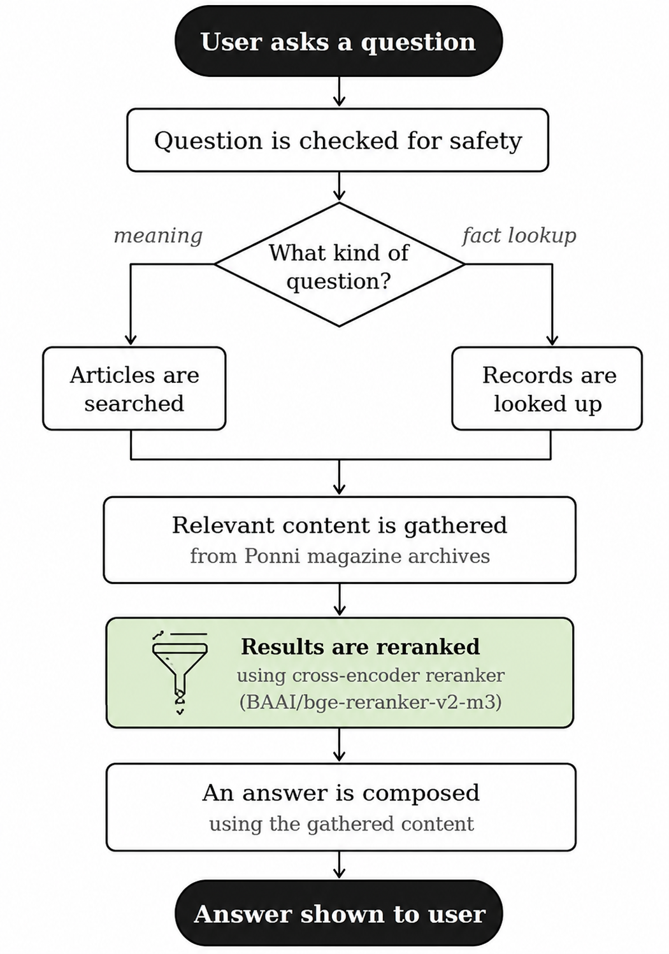
3.1 Data Ingestion and Preprocessing
Source documents are stored as PDF or DOCX files. The system reads these files and applies optical character recognition where needed for scanned pages. Character normalization is applied throughout to prevent duplicate entries from different text encodings.
An article separation engine uses configurable text patterns to detect article boundaries, extract titles, and identify authors. Each resulting article record carries structured metadata: volume ID, issue number, article number, title, author(s), word count, and language. Author names are standardized through approximate matching against a canonical registry.
3.2 Search Indexing
Articles are encoded using a multilingual embedding model that generates dense semantic vector representations for retrieval. Separate document-side and query-side embeddings are used to improve multilingual retrieval quality and cross-lingual matching between Tamil and English queries.
In addition to dense semantic representations, the system generates sparse BM25-based representations using the fastembed implementation of the Qdrant/bm25. Sparse vectors are indexed alongside dense vectors in Qdrant, enabling simultaneous semantic and lexical retrieval.
The sparse retrieval layer replaces an earlier TF-hash sparse encoder that suffered from tokenizer inconsistencies between indexing and querying. BM25 sparse embeddings improve exact phrase retrieval, keyword matching, and rare-term retrieval, which are especially important for historical Tamil archival text.
All text undergoes Unicode NFC normalization prior to indexing to ensure consistent Tamil character encoding across retrieval stages.
To further improve retrieval precision, the system incorporates a multilingual cross-encoder reranking stage using the model:
- BAAI/bge-reranker-v2-m3
The reranker evaluates query-document pairs jointly and assigns contextual relevance scores, allowing semantic comparison beyond token overlap. This substantially improves retrieval quality for Tamil morphology, paraphrased queries, and short-content search terms.
The reranking module includes:
- Lazy model loading for efficient startup behavior
- Adaptive score-based cutoff selection
- Heading-phrase prioritization for title-style queries
- Automatic fail-safe fallback to lexical retrieval when inference fails
The system also detects stale indexes and automatically triggers re-indexing when underlying document collections change.
3.3 Query Pipeline and Hybrid Retrieval
All incoming queries pass through a safety layer that detects and blocks prompt injection attempts and sanitizes input before any search or AI call is made.
Queries are then classified into two types, each handled by a dedicated pipeline as shown in Table 2.
Query Type | Example | Retrieval
Semantic | "What does Ponni say about the Dravidian movement?" | Hybrid semantic + keyword search
Structured | "List all Ponni magazine authors" | Structured database lookup
Table 2: Query routing by type
For semantic queries, the system generates both meaning-based and keyword-based search representations and merges the results intelligently.Retrieved candidates are subsequently passed through a semantic reranking layer based on a multilingual cross-encoder. The reranker jointly encodes each query-document pair and computes a contextual relevance score, enabling more accurate ranking than lexical overlap methods alone. This is particularly beneficial for Tamil, where rich morphology and grammatical suffixes often reduce the effectiveness of exact keyword matching.
To reduce inference overhead, the system includes a heading-based optimization layer. Queries are normalized and decomposed into multi-token phrases after stopword removal. Documents whose headings directly contain high-confidence query phrases are prioritized, and in clear-match scenarios the expensive reranking stage is skipped entirely.
After reranking, an adaptive cutoff strategy dynamically determines the number of evidence documents to retain. Documents are selected until relevance scores drop below configurable thresholds relative to the top-ranked result. This produces compact and highly relevant evidence sets while avoiding low-quality filler passages.
. Evidence selection is dynamic: the system selects documents up to the point where result quality drops significantly, with guardrails on minimum and maximum document counts.
Context is assembled by merging related chunks from the same article, with a character budget distributed equally across selected sources so no single document dominates the AI's input.
For structured queries (author listings, topic lookups, issue counts), the system retrieves data directly from a structured catalog using approximate title and author matching. The AI receives a lightweight prompt, and raw structured data is appended below the AI summary in the response.

3.4 Cross-Encoder Reranking
The reranking component uses a multilingual cross-encoder architecture to refine hybrid retrieval results. Unlike bi-encoder retrieval systems that independently encode queries and documents, the cross-encoder processes both jointly, enabling fine-grained semantic interaction between query and passage tokens.
The reranker uses the pretrained multilingual model BAAI/bge-reranker-v2-m3. Candidate documents retrieved through hybrid dense-sparse retrieval are passed to the reranker, which produces contextual relevance scores used for final ordering.
To improve efficiency, the system introduces several optimizations:
- Heading-phrase pinning for exact title matches
- Cross-encoder bypass for clear winner scenarios
- Adaptive score-gap filtering
- Batch inference processing
These mechanisms reduce unnecessary inference while preserving retrieval quality. The reranker is implemented with automatic fallback behavior so retrieval continues even if model loading or inference fails.
3.5 Language Model Integration
The system provides synchronous, asynchronous, and streaming interfaces to Gemini 2.5 Flash. Different prompt strategies are used for semantic versus structured queries, and question type (factual vs. yes/no) further adjusts prompt construction. A fallback mechanism returns the most relevant sentence from retrieved content when the AI is unavailable.
Conversation context is maintained across up to three prior turns, enabling follow-up queries. A caching layer stores recent query results and automatically refreshes when the underlying index changes.
4. ARTICLE CLASSIFICATION SYSTEM
Ponni RAG includes a fully offline article classification system that assigns each article one to three content category tags from a 15-category taxonomy. Classification requires no AI inference at tagging time and produces consistent, reproducible results.
4.1 Rule-Based Pattern Matching
The primary classification path matches article titles and content against category-specific keyword lists compiled from Tamil literary domain knowledge. For example, the word கவிதை (poem) in a title triggers POETRY; தலையங்கம் (editorial) triggers EDITORIAL.
4.2 Statistical Fallback
When no rule-based pattern matches, a statistical classifier trained on labeled article content assigns the most probable category. This handles articles whose titles and opening text do not contain explicit category markers — common for serialized fiction and forum contributions. The classifier operates entirely offline.
4.3 Serial Detection
Multi-part fiction articles are detected through numbering patterns in titles and content (e.g., part indicators such as பாகம், தொடர்). Detected serial articles are tagged as FICTION regardless of other signals.
5. EVALUATION FRAMEWORK
5.1 Motivation
Standard NLP evaluation metrics were designed for languages where words are clearly separated by spaces. For Tamil, such word-level metrics substantially undercount overlap since the same root word appears in many different surface forms that share no complete word token. Ponni RAG's framework operates all metrics at the character level, treating each character as a separate unit to capture partial overlap across morphological variants.
5.2 Composite Metric
The composite score combines four metrics as shown in Table 4, weighted to prioritize semantic correctness.
Metric | Weight | Method
Semantic Similarity | 50% | Meaning-based cosine similarity
BERTScore F1 | 25% | Token-level similarity via multilingual model
ROUGE-L | 15% | Character-level longest common subsequence
BLEU-1 | 10% | Character-level unigram precision
Table 4: Composite metric components and weights
The composite score is defined as:
C = 0.50·Sem + 0.25·BERT + 0.15·ROUGE-L + 0.10·BLEU-1
Score interpretation bands are given in Table 5.
Score Range | Quality | Interpretation
≥ 0.75 | Excellent | Semantically equivalent to human reference
0.55 - 0.75 | Good | Captures main facts; phrasing differs
0.35 – 0.55 | Fair | Partial answer; key details may be missing
< 0.35 | Poor | Diverges significantly from reference answer
Table 5: Composite score quality bands
5.3 Dataset and Protocol
The evaluation dataset comprises 50 Tamil question-answer pairs spanning magazine history, authors, literature, political commentary, biography, and cultural analysis. Questions range from simple factual lookups to complex multi-part analytical queries. Human reference answers were written by domain experts in Tamil literary history.
The evaluation pipeline supports both offline mode (using pre-generated answers) and live mode (invoking the running system). Results are exported with per-question metric breakdowns for error analysis.
6. SYSTEM DEPLOYMENT
6.1 API Layer
The backend exposes a comprehensive set of API endpoints covering search, question answering, author queries, topic search, library navigation, article retrieval, tag taxonomy, cache management, and health monitoring. A full endpoint reference is provided in Appendix A.
6.2 Frontend
The frontend provides five main views: a chat interface for AI question answering; a digital library browser organized by volume and issue; an embedded PDF viewer for original magazine pages; a category browse page for exploring articles by taxonomy tag; and an about page. The interface supports full bilingual operation in Tamil and English. Responses are streamed in real time.
6.3 Deployment Setup
The complete system is packaged as a containerized stack comprising three services: the search database, the backend API, and the frontend web server. AI inference is handled by Google's Gemini cloud API, removing any local GPU requirement. The system automatically detects available hardware and optimizes accordingly.
7. DISCUSSION
7.1 Challenges in Tamil RAG
Tamil's complex word structure is the central challenge throughout the system. Without a dedicated morphological analyzer in the search pipeline, keyword-based retrieval can miss relevant documents whose terms differ from query terms only in grammatical suffixes. The hybrid search approach partially mitigates this: semantic search captures meaning across word variants while keyword search catches exact or near-exact term matches. Historical OCR introduces additional noise, though text normalization handles many common artifacts.
7.2 Prompt Security
The safety layer provides protection against prompt injection attacks — attempts by malicious inputs to override system behavior, extract internal configuration, or inject unintended instructions. Detected attempts are blocked with a safe error response.
The system incorporates a multilingual cross-encoder reranking stage that substantially improves retrieval precision compared to lexical ranking alone. However, reranking introduces additional computational overhead during inference, particularly on CPU-only deployments. Although heading-based shortcut mechanisms reduce latency for title-oriented queries, future work could explore lightweight rerankers or distillation approaches for faster inference on resource-constrained hardware. The statistical classifier was trained on a relatively small labeled set; expanding the training data would improve accuracy on edge cases. Future work should explore fine-tuning Tamil-specific language models on literary Tamil, extend the evaluation dataset beyond 50 samples, and incorporate user study feedback.
8. CONCLUSION
We have presented Ponni RAG, a hybrid AI search and question-answering system for the Tamil literary archive of Ponni magazine. The system addresses the full pipeline — from document digitization and article segmentation, through hybrid semantic and keyword retrieval, to AI-synthesized Tamil responses via Gemini 2.5 Flash. A 15-category offline article tagger and a morphology-aware composite evaluation framework complement the core retrieval system. The complete system is open-source and deployable via Docker, with a modern web interface for end users and a programmatic API for developers. All code, evaluation data, and documentation are released at https://github.com/nunnarilabs/PonniRAG.
ACKNOWLEDGMENTS
We thank the contributors to the multilingual-e5-large model and the Qdrant open-source project. Ponni magazine materials are reproduced for non-commercial scholarly research purposes.
REFERENCES
[1] Lewis, P., Perez, E., et al. (2020). Retrieval-Augmented Generation for Knowledge-Intensive NLP Tasks. NeurIPS 33, 9459–9474.
[2] Wang, L., Yang, N., et al. (2022). Text Embeddings by Weakly-Supervised Contrastive Pre-training. arXiv:2212.03533.
[3] Robertson, S., & Zaragoza, H. (2009). The Probabilistic Relevance Framework: BM25 and Beyond. FnTIR 3(4), 333–389.
[4] Cormack, G. V., Clarke, C. L., & Buettcher, S. (2009). Reciprocal rank fusion outperforms condorcet and individual rank learning methods. SIGIR 2009, 758–759.
[5] Zhang, T., Kishore, V., et al. (2019). BERTScore: Evaluating Text Generation with BERT. arXiv:1904.09675.
[6] Papineni, K., Roukos, S., Ward, T., & Zhu, W. J. (2002). BLEU: a Method for Automatic Evaluation of Machine Translation. ACL 2002, 311–318.
[7] Lin, C. Y. (2004). ROUGE: A Package for Automatic Evaluation of Summaries. ACL Workshop on Text Summarization, 74–81.
[8] Google DeepMind. (2024). Gemini: A Family of Highly Capable Multimodal Models. arXiv:2312.11805
[9] Xiao, S., Liu, Z., Zhang, P., & Muennighoff, N. (2023). BGE Reranker: Large Language Model Based Text Retrieval Reranking. arXiv preprint arXiv:2312.15503.
[10] Qdrant Team. (2024). Qdrant Documentation: Sparse Vectors and Hybrid Search. Retrieved from Qdrant Official Website
[11] FastEmbed Contributors. (2024). FastEmbed: Lightweight Embedding Generation Library. Retrieved from FastEmbed GitHub Repository

